Let Our Traditions Be Seen
At Winter Carnival 2017
(Trout River PTA)

February 13-18

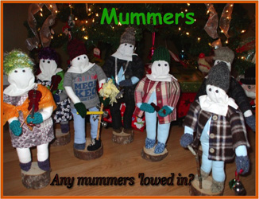

Schedule of Events

Monday, February 13
8:15 am Opening Student Breakfast @ Jakeman

9:10 am Winter Carnival Opening
Assembly @ Jakeman

Best Decorated Door @ Jakeman
Start decorating your door
(Newfoundland Theme)
Judging on Friday (Team Points)
Coloring Contest Preschool – Grade 2
Pick Up Coloring Sheets
At Jakeman All Grade, Local Business Establishments or Post Office
Drop off to Jakeman All Grade by noon on Friday

After School Snowshoeing/Skiing
Jakeman All Grade

6:00 pm Volleyball Spirit @ Jakeman
$2.00 per Player/Spectator
$1.00 with button
Grade 7 and up
Adults Welcome
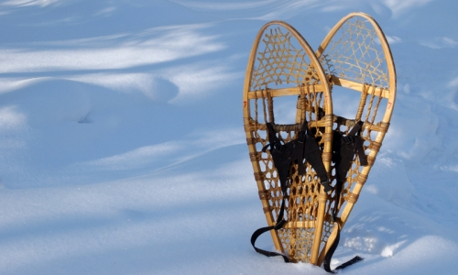
Tuesday, February 14
Community Snow Sculpture Registration
$5.00 per Sculpture
Register by: 5:00 p.m.
Call Lorraine @451-2175
1st, 2nd and 3rd Prizes
(Winners Announced at Closing)
5:00 p.m. Potluck Supper @ Lions Hall
(Bring your Newfoundland Dish & Instrument)
Carnival Buttons

Purchase your carnival button for just $1.00 starting on
Wednesday, February 8, 2017

Buttons available @ Town Office,
Local Business Establishments or Post Office

Lucky button number will take home a prize valued between $25.00-$50.00
All proceeds will go to the PTA for future use for Jakeman All Grade School
The Students Number that is drawn will also get a small prize

The winning # will be drawn during "Closing Ceremony” on Saturday @ 4pm. (Winner does not need to be present to claim prize, winnings can be picked up at Jakeman All Grade).

Thank you for your support!!

Wednesday, February 15
3:30 pm Family Scavenger Hunt
Meet at the Town Hall @3:30 pm
Return to Town Hall by 5:00 pm
Treat for all participants

Thursday, February 16
6:00 p.m. NewCombe @ Jakeman
Grade 3 and up

8:00pm PRIZE BINGO
At the Rusty Jigger
Hosted by PTA
Sponsored by Recreation

Friday, February 17
Deadline @ noon to Bring your Coloring Contest Sheets to School
Judging for Coloring Contest & Best Decorated Door @ Jakeman
Before the end of the school day

4:00 pm Mummers Parade
Meet@Town Hall@ 4:00 pm
Walking to Lions Hall
Snack at Lions Hall
Donated by
50t Seniors Club

Saturday, February 18
11:00 am Boil Up
All events held during Winter Carnival are
"USE AT OWN RISK"

Up the Feeder
- Homemade Sled Races
- Snowshoe Races
- Tug of war
- Wiener & Marshmallow Roast
- Smores
- Hot Chocolate
Bring your Homemade Sleds (Must Be made with Cardboard and duct tape), Snowshoes & a Mug & enjoy your day up the feeder

4:00 pm Closing Ceremony
Fashion Show
At Lions Hall

7:30 pm Darts & Scat
1st & 2nd Prize for Darts
1st 2nd & 3rd Prize for Scat
$5.00 per Person
At Lions Hall

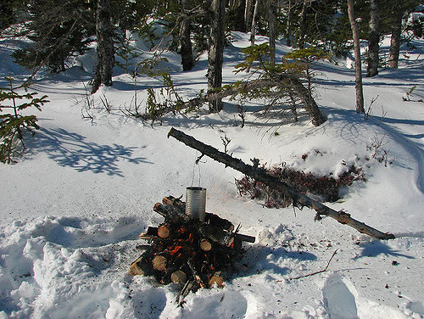

Special Thanks to everyone who
hosted events, Sponsored events, donated and helped to make Winter Carnival 2017 possible

PTA will also be selling Tickets on a Basket of Baked Goods (White Bread, Raisin Bread, Raisin Buns, Meat Pie etc.)
$1.00 each
Will be available for pick up Saturday @ Lions Hall

